SECOND SUNDAY OF EASTER
April 28, 2019

WE GATHER IN THE presence OF GOD
Gathering Music
Welcome, Announcements, & Greeting Time Brice Smith
Prelude “Are Ye Able” Jan Mauck, Church Pianist
*Easter Greeting:
Alleluia! Christ is risen!
He is risen, indeed! Alleluia!
*Song 293 “Christ Is Risen! Shout Hosanna!” Polish Folk
314 “Easter Song” Easter
*Call to Worship
Praise the Lord!
Praise God in his sanctuary;
Praise him in his mighty firmament!
Praise him for his mighty deeds;
Praise him according to his surpassing greatness!
Praise him with trumpet sound;
Praise him with lute and harp!
Praise him with tambourine and dance;
Praise him with strings and pipe!
Praise him with clanging cymbals;
Praise him with loud clashing cymbals!
Let everything that breathes praise the Lord!
Praise the Lord!
Psalm 150:1-6 - New Revised Standard Version
*Song 323 “Hail the Day that Sees Him Rise” Llanfair
*Invocational Prayer
*Alleluia 320 "Alleluia! Sing to Jesus” Hyfrydol
The Prayers of God’s People – OUR FATHER, who art in heaven, hallowed be thy name. Thy kingdom come, thy will be done, on earth as it is in heaven. Give us this day, our daily bread. And forgive us our debts, as we forgive our debtors. Lead us not into temptation but deliver us from evil. For Thine is the kingdom, and the power and glory, forever.
WE HEAR THE WORD OF THE LORD
A Reading from Church History Acts 5:27-32
A Reading from the Apostles Revelation 1:4-8
*A Reading from the Gospel John 20: 19-31
*Song 305 “He is Lord” Philippians 2:10-11
Invitation to Give and Prayer of Dedication
Offertory Special

Children’s Message (2nd Grade and younger to Junior Church)
Message: “Easter Changes Everything!”
The Reverend Doctor Ivan E. Greuter, Senior Minister

RESPONDING TO THE HOLY SPIRIT IN FAITH & SERVICE
*Invitation to Faith and Fellowship – If the Spirit of God is moving you to receive God’s forgiving love in Jesus, calling you to be a follower of Jesus in the waters of baptism, or encouraging you to join this Christian Church, please come forward during this song.
*Closing Song “In Christ Alone” WT
*Spoken Benediction
*Postlude Jan Mauck, Church Pianist
*Please stand if able
EASTERTIDE - Christ has died, Christ is risen, Christ will come again! The celebration of the resurrection begins on Easter Sunday and continues throughout the year, with each Sunday a “little Easter.” Eastertide is a fifty-day celebration after Easter and is known for the Post-Resurrection appearances when Jesus taught his Apostles and followers before the glorious Ascension. During this time, we celebrate with an Easter Greeting and an extra “Alleluia!”
BELIEVER’S BAPTISM – American Baptist Churches practice “believer’s baptism” which is the immersion of a person in water – regardless of age – who receives Jesus Christ as his/her personal Savior and publicly professes faith to walk the Jesus way. The Council schedules baptisms on most Sunday mornings throughout the year. If you would like to be baptized, then come to the front of the church during the last song.
THE LORD’S SUPPER – American Baptist Churches celebrate the Lord’s Supper (Holy Communion) on the first Sunday of each month as a sign of our unity as the one, holy, universal Christian church. We practice “open communion” which means the Table of the Lord is open to all baptized followers of Jesus regardless of affiliation or membership. In solidarity with our brothers and sisters, we use only non-alcoholic grape juice. Please hold each element until everyone is served, then we will feast together.
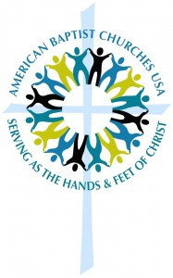
American Baptist Church USA – American Baptist Churches USA (ABCUSA) is one of the most diverse Christian denominations today, with approximately 5,000 local congregations comprised of 1.3 million members across the United States and Puerto Rico.
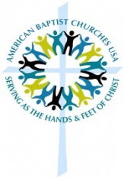
American Baptist Church, USA
www.abc-usa.org

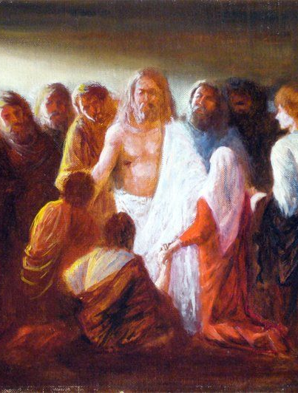
“My Lord and My God!”
WEST SIDE BAPTIST CHURCH 1008 SW Fourth Street │ Topeka, KS 66606 Phone: (785) 233-4241 │ office@wsbctopeka.org www.wsbctopeka.org

